Dis-ME-Syro-Hittite-Figurine-Anthropomorphic Bird-Pillar Base-2800 – 1900 BCE

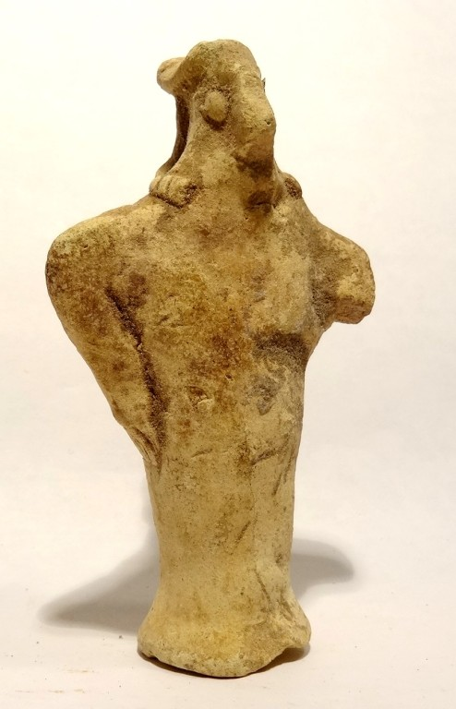 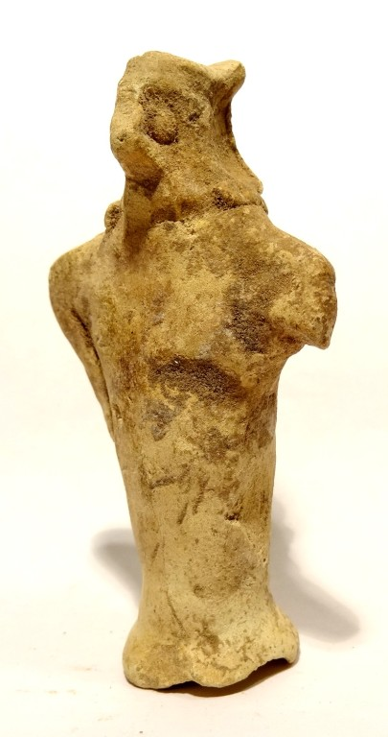 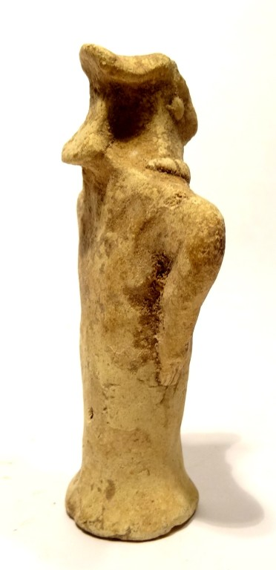 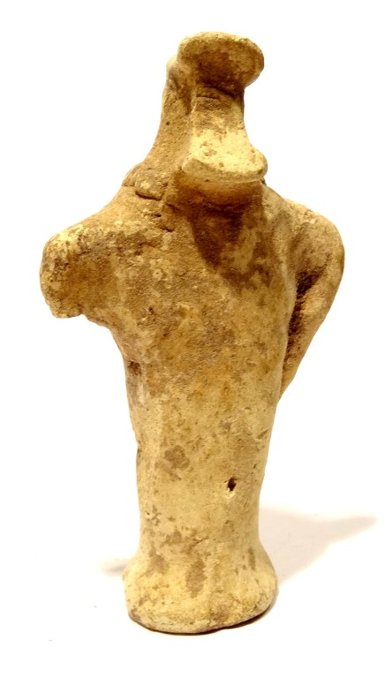 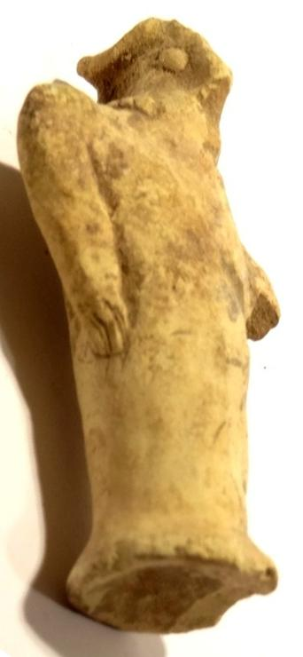

Syro-Hittite-Figurine-Anthropomorphic Raptor-Pillar Base-2800 – 2600 BCE

Case 2

Accession Number

Formal Label: Syro-Hittite-Figurine-Anthropomorphic Raptor-Pillar Base-2800 – 2600 BCE

Display Description:

This Syro-Hittite ceramic figurine with a solid pillar base has a pointed beak like a raptor and pellet shaped eyes suggestive of its superior vision. However, its arms akimbo, positioned like wings and its necklace suggests it is anthropomorphic.

Accession Number:

Date or Time Horizon: 2800-2600 BCE

Geographical Area: n Syria- s Anatolia

Cultural Affiliation: Syro-Hittite

Medium: Terracotta

Dimensions: H 78 mm

Weight:

**Condition**: One arm is missing, else very good. Hard and attractive patina, with calcareous adhesions.

**Discussion:** Among the Syro-Hittite people the deceased were put on scaffolds or left in the open to allow raptors like the vulture, the hawk and the owl to consume the body of the deceased (excarnation) in order to assume its wisdom. This anthropomorphic bird figurine may be model of a vulture priest who would prepare the body for this event. At Çatal Hüyük in south central Anatolia (Turkey) the excarnation ritual is depicted on the walls of its vulture shrines ca 6500 BCE

**References:**

Sold by [ancient_artonlin...](http://myworld.ebay.com/ancient_artonline) ( [1879](http://feedback.ebay.com/ws/eBayISAPI.dll?ViewFeedback&userid=ancient_artonline) )

Estimated delivery Tuesday, Dec 13, 2016 - Friday, Dec 23, 2016

#### [RARE STATUETTE IDOLE - VALLEE EUPHRATE- SYRO HITTITE 2600 BC - NEAR EASTERN IDOL](http://www.ebay.com/itm/201717385940)

|  |  |
| --- | --- |
| Item price | $175.90 |
| Quantity | 1 |
| Item number | 201717385940 |
| Shipping service | La Poste - Courrier International Prioritaire |